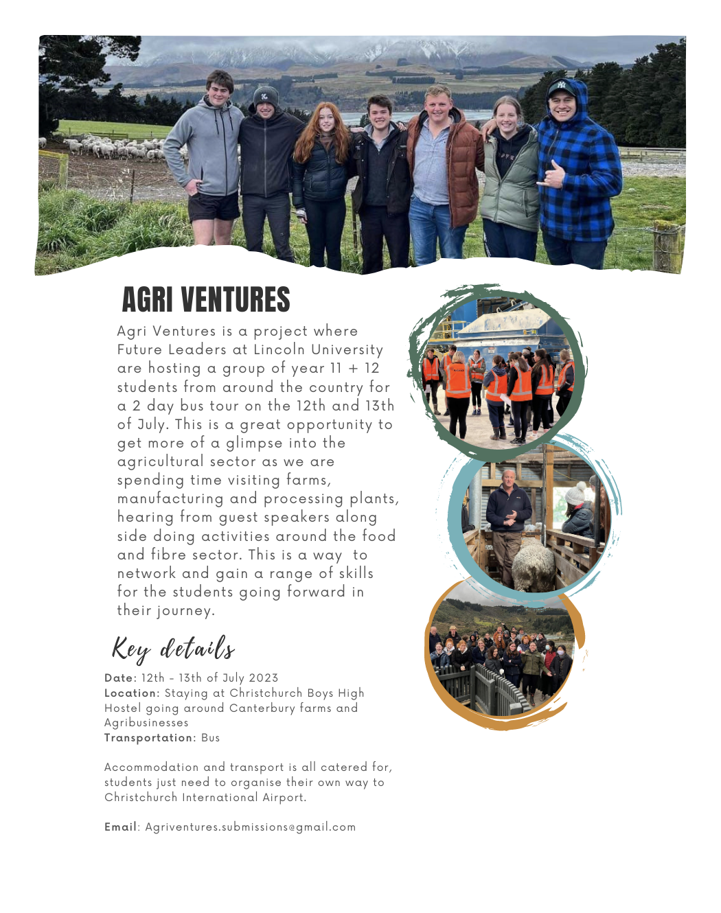

AGri ventures
  - Future Leader Project

Application form
Please return form to Agriventures.submissions@gmail.com
For Due Date : 29th May 2023

Personal Details
Full name: ____________________________________________________
Preferred Given Name : ____________________________________________________
Date of Birth : ____________________________________________________
T shirt size : ____________________________________________________
School name: ___________________________________________________

Year levels (please circle)
Year 11
Year 12
List of subjects studied :

Contact Details
Address : _____________________________________

Email address: _____________________________________
Phone number: ____________________________________

Emergency Contact Details
Full name: _________________________________________________
Relationship: _____________________________________________
Address : _________________________________________________
Home Phone number: ____________________________________________
Cell Phone number: _____________________________________________
Email address: _______________________________________________

Allergies/Dietary Requirements
Please list any medical conditions (including medications) we may need to be aware of:

Please note any dietary requirements :

Parent/Guardian Consent
As the legal guardian of ….............................. I hereby give permission for my child to participate in this event. I acknowledge the Code of Conduct and understand that failure to adhere to this will result in my child being removed from the programme.
Name: _______________________________________________
Date : _______________________________________________
Signature : _______________________________________________

Code of Conduct
In order to create a safe and happy environment this code of conduct contains rules and regulations students must abide by while on the Agri Ventures trip.
- No alcohol, smoking or drugs
- No leaving the Christchurch Boys High School Hostel grounds without permission
- Show respect, care, concern and consideration for others
- Respect our environment
- Please respect the farms and business we visit as well as the people hosting us
- Please respect the Christchurch Boys High School Hostel. Keep it clean and tidy and do not damage or allow it to be damaged in any way.
During Agri Ventures I will :
- Follow this code of conduct
- Accept decisions made by the staff and project leaders
- Show consideration for everyone on the camp
- Take care and respect the buildings, surroundings and people visited
Students signature : _______________________________________________
Parent/Guardian’s signature : _______________________________________________

Video and Photograph Release
I agree to the use of video and/or photographs of myself to be used by Lincoln University and other media platforms. These images may be used in materials to promote Lincoln University, Lincoln Future Leaders and for publicity purposes, such as newspaper features, video and website. The material can be used by the Student Engagement team or any other division, subsidiary or centre of Lincoln University, including the Lincoln University Students’ Association.
Students signature : _______________________________________________
Name : _______________________________________________
Date : _______________________________________________

Questions
Tell us a bit about yourself? (Max 500)

Outline your future career interests (Max 300)

What is your main reason(s) for wanting to come on the Agri ventures 2023 trip? (Max 500)

What do you feel you would gain from going on the Agri ventures trip? (Max 500)

You can answer these questions as a video and email them through to Agriventures.submissions@gmail.com

